Ronak Chavva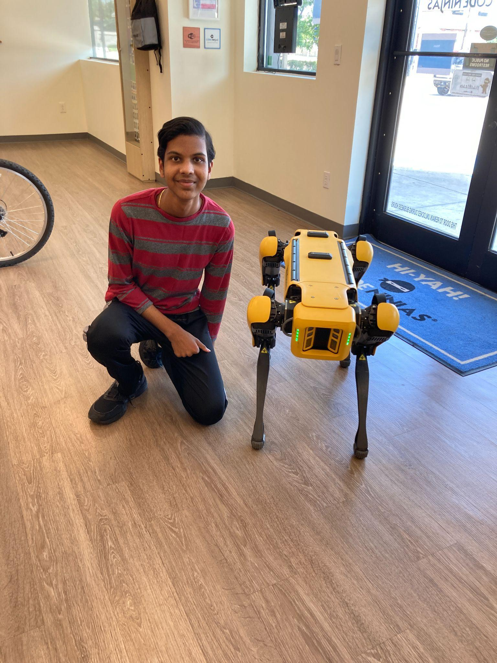

ronakch8@gmail.com

Senior

University of Texas - Dallas

I made most of the UI for our game, ~~Gogglesnort~~ The Day After. The Main Menu was made in collaboration with Thomas. It consists of a play button which puts you into the game at a set spawn location, a settings button which allows you to configure various controls (read more about it in Toby Huang’s Bio), an element created in collaboration with Toby, as well as a quit button which simply exits out the game. I made the Pause Menu , which pauses game time and basically freezes the game, which consists of a resume button that resumes time, another settings menu which consists of what was described above, and a quit button that redirects you back to the Main Menu. I made the template for the shop menu that has all but the functional aspects included.